PRODUCT DESCRIPTION
PTFE (Polytetrafluoroethylene) Felt, Pledget and strip are used in many surgical applications including cardiovascular surgery, especially as suture line support material and tissue support-repair material and prevent tissue tearing. It has fibrous structure, soft and constant density. It accelerates healing by stimulating fibrosis due to its fibrous structure. It is compatible with the tissue.

MODELS AND DIMENSIONS
Felt; It is used as tissue support material together with the suture line in organ repair.
Strip; It is used as a tissue support material together with the suture line in tissue repair.
Pledget; It is used as a tissue support material together with the suture line in the repair of vascular wounds.

Product Code | Size | Product Name
GE-PF1010 | 10,2CMX10,2CM | PTFE TEFLON FELT 10,2CMX10,2CM
GE-PF1515 | 15CMX15CM | PTFE TEFLON FELT 15CMX15CM
GE-PF7515 | 7,5CMX15CM | PTFE TEFLON FELT 7,5 CMX15CM
GE-PFP3X6(5) | 3X6(5) | PLEDGET 3MMX6MM (5 PCS)
GE-PFP3X6(10) | 3X6(10) | PLEDGET 3MMX6MM (10 PCS )
GE-PFP4X4(5) | 4X4(5) | PLEDGET 4MMX4MM (5 PCS )
GE-PFP4X4(10) | 4X4(10) | PLEDGET 4MMX4MM (10 PCS )
GE-PFP6X6(5) | 6X6(5) | PLEDGET 6MMX6MM (5 PCS )
GE-PFP6X6(10) | 6X6(10) | PLEDGET 6MMX6MM (10 PCS )
GE-PFP6X9(5) | 6X9(5) | PLEDGET 6MMX9MM (5 PCS )
GE-PFP6X9(10) | 6X9(10) | PLEDGET 6MMX9MM (10 PCS )
GE-PFS0515 | 0,5X15 | STRIP 0,5X15CM
GE-PFS115 | 1X15 | STRIP 1X15CM
GE-PFS1515 | 1,5X15 | STRIP 1,5X15CM
GE-PFS0510 | 0,5X10 | STRIP 0,5X10CM
GE-PFS110 | 1X10 | STRIP 1X10CM

PTFE Teflon Felt | PTFE Teflon Pledget | PTFE Teflon Strip
 | 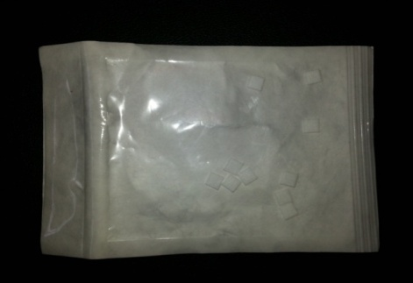 | 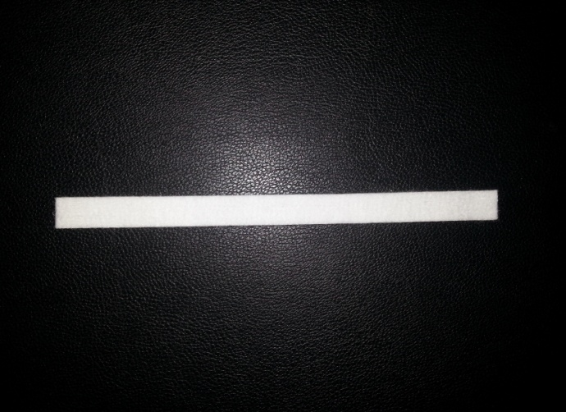

PRODUCT INTENDED USE and INDICATIONSPTFE

Felt, Pledget, and Strip products are non-absorbable implantable support materials used in conjunction with sutures during surgical procedures. Their intended purpose is to reinforce the suture line, distribute suture tension, and prevent tissue cut-through in order to support wound healing.
These devices function solely as adjunctive suture-line reinforcement materials and are encapsulated with connective tissue after implantation, thereby providing additional mechanical support to the tissue.
As a reinforcement/support material under the suture line in cases where the surgical suture may risk tearing fragile tissue.
In various surgical suturing procedures (e.g., vascular suturing, septal closure, valve suturing, myocardial repair, liver or other soft tissue suturing) where additional suture-line support is clinically required.
For surgical situations requiring improved distribution of suture tension across the tissue to prevent localized tearing.
Important Note:
The device is not indicated as a patch, is not intended to close tissue defects independently, and is not indicated as a substitute material for ventricular myocardium or other organ/tissue replacement.
Expected Clinical Benefit from the Product
It can be used as a tissue support material and prevents tissue tearing in suturing procedures.

PATIENT POPULATION
It is used in patients who need to be used as a support material in surgical intervention and especially in suture line operations to provide non-absorbent tissue protection during surgical suture procedures. These are patients who require surgical interventions, including cardiac surgery, and support material for the suture line. It can be used in female or male patients in accordance with its intended use. For use in individuals aged 18 and over

USER PROFILE
The device can only be applied by a doctor who is fully responsible for the surgical and post-operative procedures of the system and can manage potential problems. The correct selection of the application area, thickness and size of the "PTFE Felt" for each patient is extremely important for the successful implementation of the procedure. Therefore, the device must be used by a healthcare professional / doctor (operator surgeon). The product should be kept away from children.
- Must be a specialist physician who has completed the necessary training.
- Must have operation experience.
- Must have high attention ability during the procedure.
- Must have technical knowledge about the use of products.

PRODUCT REAPPLICABILITY
The product is disposable and the same product used should not be used again in the patient. However, the procedure application is repeatable. There is no restriction on repeat application. Re-application should be decided by physicians according to the patient's condition.

MECHANISM OF EFFECT
Patch, cardiovascular: An implanted extravascular device used during surgery to reinforce a fragile vascular territory or to close openings in arteries. The mechanism of action of this product works by forming a tissue support-repair material by encapsulation with connective tissue.
While the product shows the specified effect, it does not show any chemical or biological reaction. Therefore, with the realisation of implantation, it shows a physical effect in accordance with the intended use.

CONTRAINDICATIONS

Use of the product is contraindicated in patients with:

Acute or chronic, local or systemic infection,

Muscular, neurological or vascular insufficiency impairing healing,

Known allergy or hypersensitivity to PTFE,

Severely compromised tissue condition,

Active systemic or metabolic disorders that interfere with wound healing,

Active infectious diseases or toxaemia,

History of excessive drug or alcohol abuse that may compromise recovery.

WARNINGS AND PRECAUTIONS
Warnings:
- When used for continuous fastening, care should be taken with surgical splicing tapes to assure the strength of the knots.
- Do not expose PTFE products to temperatures greater than 550 degrees F (260 degrees C). PTFE decomposes at high temperatures and forms highly toxic decomposition agents.
- Dispose of the unused portion of the products in the medical waste bin.
Precautions
- The product sterilisation bag must be opened in the operating room, which is a sterile environment, immediately before the operation and should not be used with bare hands to prevent contamination caused by the user in the application.
- The product should only be used by surgeons specialised in related operations.
- The size of the product to be used in the operation may vary depending on the decision of the surgeon who will perform the operation.
- The surgeon should have different sizes of PTFE Felt with him/her to use when a different size is required.
- Before use, it should be checked whether the package is damaged in terms of sterility of the product.
- Contact of the product with any object should be avoided.
- The product should not be reused under any circumstances.
- It should be transported and stored in environments away from direct sunlight.
- The user manual must be read carefully before using the product.
- Products with torn and damaged packages are not sterile and should not be used.
- Transport and storage must be done in such a way that the packages are not damaged.
- Heavy materials should not be placed on the boxes during sorting.
- Products with expired expiry dates should not be used.
- This product must not be sterilised again under any circumstances.
- The entire product or the remainder of the product must not be re-sterilised by the purchaser.
- Nevertheless, the manufacturer and supplier accept no responsibility if the product is re-sterilised.
- If there is a foreign substance in the product during the use of the product and if it is used, it causes infection, toxic effect for the patient. If there is foreign matter in the product, the product should not be used.
- Linting or disintegration of the product during use and falling of particles into the heart or vein as a result of use may cause micro embolisation and tissue loss. The linting or disintegrated product should not be used by the physician.
- If the product deteriorates during use and this product is used, the expected performance of the product cannot be obtained. It causes prolongation of treatment. Deteriorated products should not be used.
- If force is applied during product use and the product deteriorates and is used, the product cannot be expected to perform as expected. No force should be applied to the product and it should not deteriorate.
- Avoid excessive touching of the felt surface prior to use.
When cutting Felt into smaller pieces, it is important to use a sharp cutting device (scalpel) or scissors with sharp blades to ensure that the Felt fibres are cut smoothly and not pulled apart.

MRI COMPATIBILITY AND EXTERNAL INFLUENCES

MRI Safety: This device is MR Safe. The PTFE material is non-ferromagnetic and does not pose any known hazards in all MRI environments.

Magnetic Fields: The device is not affected by magnetic fields and does not interfere with MRI imaging.

Electromagnetic Effects: The inert PTFE material is not susceptible to electromagnetic interference.

Temperature Variations: The device maintains its integrity within the specified storage range (15-25°C) and normal body temperature.

Pressure Variations: The device structure remains stable under normal physiological pressure conditions

STERILITY, STORAGE and SHELF LIFE INFORMATION
The product is sterile and sterilised by EtO method. The shelf life of the product is 3 years. The product can be used until the expiry date indicated on the label. The product should be stored between 15-25 ºC, protected from direct sunlight and moisture.

PRODUCT REAPPLICABILITY
This product is for single-use only and should not be reused on the same patient. However, the procedure is repeatable. There is no restriction on repeat applications. Reapplication should be determined by the physician based on the patient's condition.

MECHANISM OF ACTION / INSTRUCTIONS FOR USE
Patch, cardiovascular: An implanted extravascular device used during surgery to reinforce a fragile vascular territory or to close openings in arteries. The mechanism of action of this product works by forming a tissue support-repair material by encapsulation with connective tissue.
While the product shows the specified effect, it does not show any chemical or biological reaction. Therefore, with the realisation of implantation, it shows a physical effect in accordance with the intended use.
Instructions for Use:
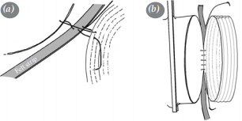 | - The Teflon felt strip is placed outside the vein-application site.  - The felt is started to be sutured to the tissue with a non-absorbable double needle, semicircular suture.  - During suturing, the process is performed by leaving a gap of 4-6 mm between the suture from the outer surface to the felt graphical surface, from the outside to the tissue surface, from the tissue surface to the felt surface.

Since the material it is produced from is not absorbed and does not degrade, it remains in the body for a lifetime in the area where it is used.
If needed, a new piece can be cut and reused.
The product provides lifelong support, since it is not absorbed and does not degrade, it shows its lifelong effect in the body, in the area where it is used. A new product is used when needed. The part in the body is not reused.
In case of any complication arising from the product in the patient;
- Removal of sutures used in the application of the product,
- Removal of the product from the area where it is used so as not to damage any tissue,
- In order to prevent damage (blood loss, etc.) that may occur in the area where the product is removed, it should be supported with another material.

PRODUCT CONTENT
The product does not contain any medicinal substances, animal tissues or blood components.

SIDE EFFECTS and COMPLICATIONS
Possible complications that may occur with the use of these products or any vascular implant procedure include infection and tissue erosion. (TF-07.11 Clinical Evaluation Report, Literatures and Equivalent Product Documents)
Thrombus formation, anastomotic blood leakage, peripatch seroma formation, pseudoaneurysm formation and haematomas are among the complications that may occur.
Complications such as haemorrhage, infection and blood leakage may occur. (TF-07.11 Clinical Evaluation Report, Literatures and Equivalent Product Documents)
The product may show side effects when applied in patients with PTFE allergy.

NECESSARY EQUIPMENT
The subject devices (PTFE Felt, Pledget, and Strip) are supplied sterile for single-use and do not include accessories in their packaging. However, the following accessories are typically required for their intended surgical use:
Non-absorbable sutures with a tapered needle
Standard surgical instruments (e.g., needle holders, forceps, scissors, clamps)
These accessories are not supplied with the device but are commonly available in the surgical environment and must be provided by the operating team.

DRUG INTERACTIONS
The product has no known drug interaction.

DISPOSAL
Used devices may be contaminated with blood or body fluids and should be considered as potential biohazard. Dispose of all used and unused portions according to: - Applicable local laws and regulations for medical device disposal - Accepted medical practice for contaminated medical devices - Hospital waste management protocols - Medical waste disposal requirements Dispose of the unused portion of the products in the medical waste bin.

PRODUCT USAGE
Surgical invasive use is involved.

SSCP
The Summary of Safety and Clinical Performance (SSCP) for this device is available in the European database on medical devices (Eudamed) and can be accessed using the Basic UDI-DI. For more information, please visit the Eudamed public website: https://ec.europa.eu/tools/eudamed
The corresponding SSCP document is: RP.18.03 Summary of Safety and Clinical Performance (SSCP) Report, Rev. 00.

Performance and Safety Specifications
The safety and performance requirements of our product have been determined in line with market and user needs and 2017/745 MDR and other requirements.

Product Name | Security Criteria |  | Result
PTFE Teflon felt, pledget, strip | Biological Safety | It should not show pyrogenic effects due to manufacturing or material. | It complies with the requirements of the EN ISO 14644 standard series.  It complies with the requirements of the EN ISO 10993 series of standards.  It complies with the requirements of the EN ISO 14937 standard.
PTFE Teflon felt, pledget, strip | Biological Safety | It should not contain risks related to biocompatibility.
PTFE Teflon felt, pledget, strip | Biological Safety | Should be sterile
PTFE Teflon felt, pledget, strip | Physical Security | The surface should have a porous structure compatible with the tissue and should be of appropriate thickness. | It complies with the requirements of ASTM D 5729, ASTM D3776, ASTM D5034, ASTM D 3786 standards.
PTFE Teflon felt, pledget, strip | Product site safety requirements | Product production is carried out in a clean room with ISO 7 air cleanliness class. The product is packaged in this clean room. | .  It complies with the requirements of the EN ISO 14644 standard.
PTFE Teflon felt, pledget, strip | Product sterilization requirements | The products are subjected to an 18-hour sterilization process with Ethylene oxide in accordance with the requirements of EN ISO 14937 standard. | It complies with the requirements of the EN ISO 14937 standard.
PTFE Teflon felt, pledget, strip | Biocompatibility Requirements | Material that complies with the requirements of the EN ISO 10993-1 standard must be used. | As a requirement of EN ISO 10993-1 standard;  İrritaston EN ISO 10993-10  Cytotoxicity EN ISO 10993-5  Sensitization EN ISO 10993-5  Acute Systemic Toxicity EN ISO 10993-11  Subacute Toxicity  Subchronic Toxicity  Chronic Toxicity  Implantation  Pyrogenicity  Genotoxicity  carcinogenicityThe subjects were evaluated and determined to be biocompatible.

PACKAGE INFORMATION
For Felt: Polyethylene film is sold as 1 piece in a package.
For Pledget: Polyethylene film is offered for sale as 5 or 10 pieces in a package.
For Strip: It is offered for sale as 1 piece in a polyethylene film package.


GEMED Sağlık Ürünleri San. Ve Tic. Ltd. Şti.
Hürriyet Mah. Adnan Kahveci Cad. No:27/B, 34876 Kartal, Istanbul, Türkiye
e-mail: info@gemed.com.tr
web: www.gemed.com.tr
Phone: +90 216 452 35 25
Fax: +90 216 451 11 22

Reporting of Adverse Events / Serious Incidents
Any serious incident that occurs in relation to the use of this device must be reported immediately to the manufacturer and to the competent authority of the Member State in which the user and/or patient is established. Users should follow local regulations for reporting medical device incidents. Contact information for the manufacturer is provided in the IFU.

EXPLANATION OF SYMBOLS USED ON THE LABEL

 | Manufacturer Information |  | Production Country Code/Production Date
 | Expiry Date |  | Do not re-sterilise
 | Lot Number | 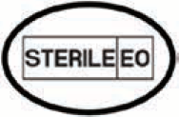 | Sterilised with Ethylene Oxide/Packaged with Single Sterile Barrier System
 | Reference Number |  | See User Manual
 | Single use only |  | Caution. Refer to the User Manual.
 | Protect away from sunlight |  | Keep Dry
 | Unique Device Identifier |  | Medical Device
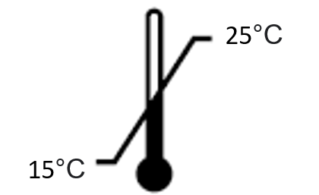 | Keep within the specified temperature range (15-25) |  | Do not use if the package is damaged
Qty | Product Quantity
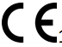 | Mark of Conformity to the Medical Device Regulation and Identification Number of the Notified Body Granting CE Approval (2797)

